My Project Title

Lee Wilkins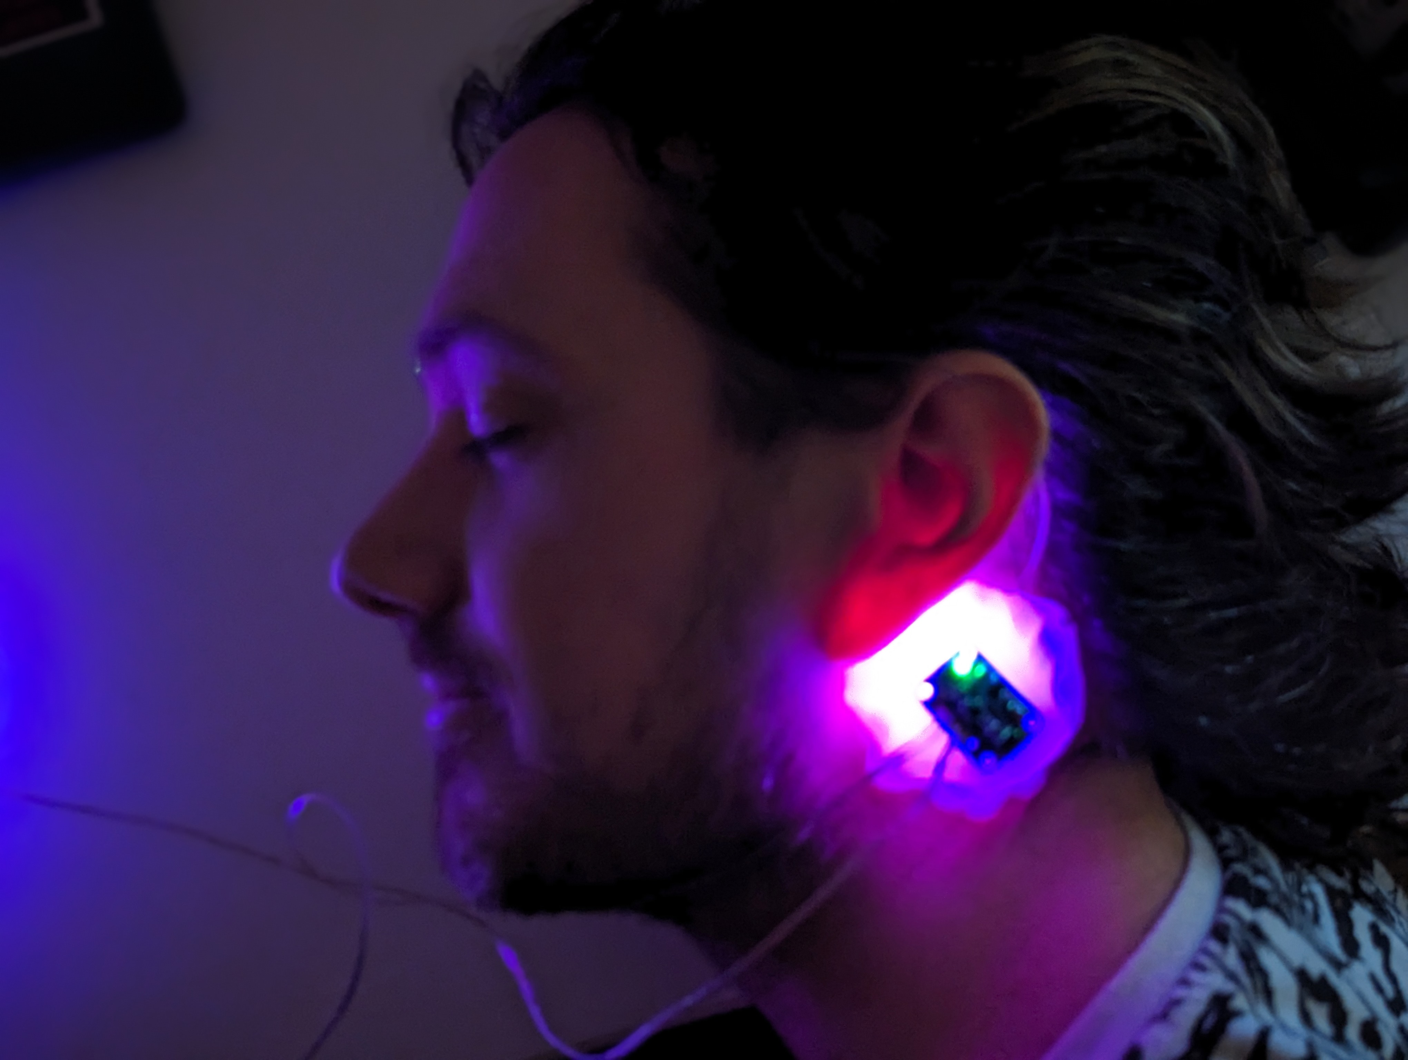

**Main Image:**

Include a clear, strong image of your work. If the work is just audio, include an image of whatever context you imagine it in.

**Artist Statement:**

Write an artist statement that describes your work. Describe the work as though it is on a gallery wall, what would you read? 50-100 words. Remember, even a small project should have some kind of theme or concept. What do you want people to experience while viewing your work?

A good place to start is:

[Project Name] is an exploration of [concept]. By using [something, audio, video, samples from something?] viewers are able to experience [what do you want them to feel?].

**Technical Explanation:**

Explain how it works, and your process getting there. Ex: I used the camera and counter objects to create an interactive display that counted the number of people who pressed the button. I expanded on what we did in class by using the jit.rota object.. I had trouble with [something] so I used [something else].

**Image of patch:**

Take a clear screen shot of your patch(s) or sub patch.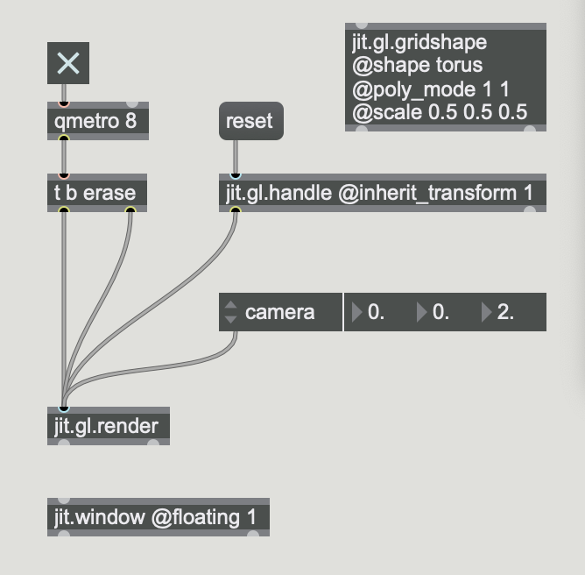

**Link to video**

Link to the video on GitHub, YouTube, Google Drive, One Drive, or wherever. Test the link to make sure I have access.

**Image of circuit**

If you used an Arduino or other physical things, take a picture of them.

**List of references**

List any tutorials or resources you used.

**Upload your .maxpat to Moodle, Save this file as a .pdf.**